PIZZA SALES PROJECT

**KPI’s**

select * from pizza_sales;

**1. Total Revenue:**

select sum(total_price) as Total_Revenue from pizza_sales;

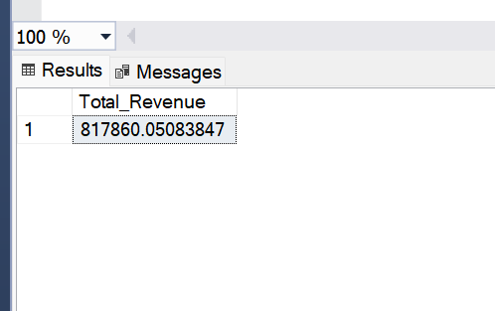

**2. Average Order Value**

select sum(total_price)/count(distinct order_id) as Avg_Order_Value from pizza_sales;

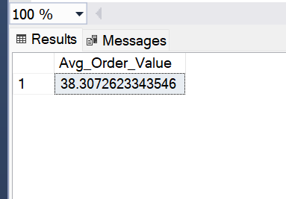

**3. Total Pizzas Sold**

select sum(quantity) as total_Pizzs_Sold from pizza_sales

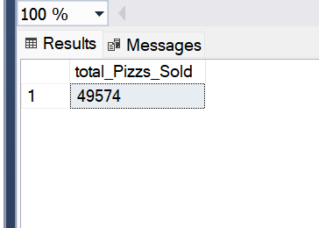

**4. Total Orders**

select COUNT(distinct order_id) as Total_Orders from pizza_sales

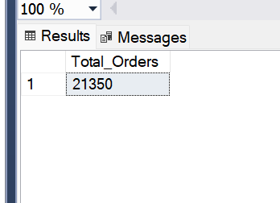

**5. Average Pizzas Per Order**

select CAST(cast(sum(quantity) as decimal(10,2))/ CAST(count(distinct order_id)AS decimal(10,2)) AS DECIMAL(10,2)) as Avg_pizza_per_order from pizza_sales

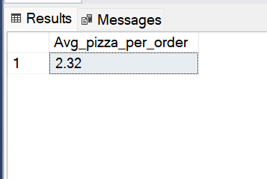

**6. Daily Trend for Total Orders**

select DATENAME(dw,order_date) as order_day, count(distinct order_id ) as Total_orders from pizza_sales

group by DATENAME(dw,order_date)

order by DATENAME(dw,order_date) asc;

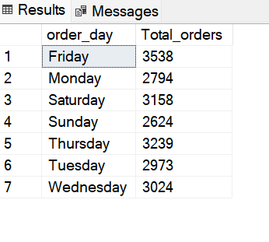

**7. Monthly Trend for Orders**

select DATENAME(month,order_date) as Month_Name , count(distinct order_id) as Total_Orders from pizza_sales

group by DATENAME(month,order_date)

order by Total_orders desc;

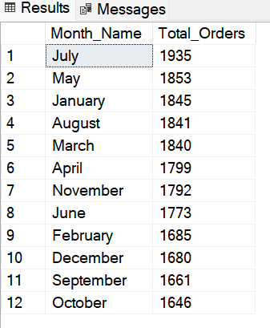

**8. % of Sales by Pizza Category**

select pizza_category,CAST(SUM(total_price) AS DECIMAL(10,2)) as

total_revenue,

sum(total_price)*100/(select sum(total_price) from pizza_sales) as PCT

from pizza_sales

group by pizza_category;

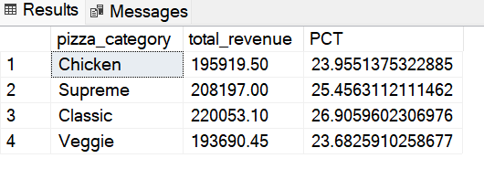

**9. % of Sales by Pizza Size**

SELECT pizza_size,cast(sum (total_price)as decimal(10,2)) as Total_Revenue ,CAST(sum(total_price)*100/(select sum(total_price) from pizza_sales) AS DECIMAL(10,2))as PCT from pizza_sales

group by pizza_size

order by PCT desc;

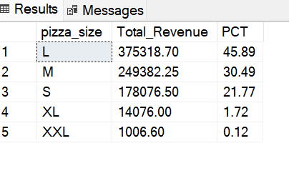

**10. Top 5 Pizzas by Revenue**

SELECT TOP 5 pizza_name,sum(total_price) as Total_Revenue from pizza_sales

group by pizza_name

order by Total_Revenue desc

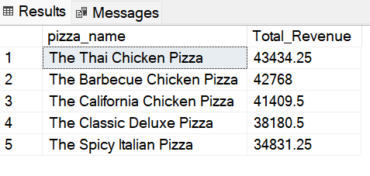

**11. Bottom 5 Pizzas by Revenue**

SELECT TOP 5 pizza_name,sum(total_price) as Total_Revenue from pizza_sales

group by pizza_name

order by Total_Revenue asc

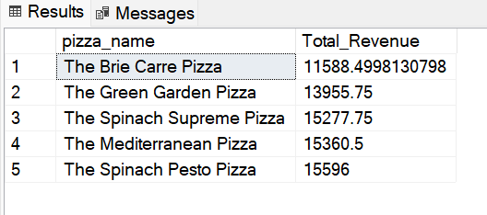

**12.Top 5 Pizzas by Quantity**

SELECT TOP 5 pizza_name,sum(quantity) as Total_Quantity from pizza_sales

group by pizza_name

order by Total_Quantity desc

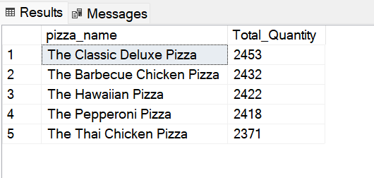

**13. Bottom 5 Pizzas by Quantity**

SELECT TOP 5 pizza_name,sum(quantity) as Total_Quantity from pizza_sales

group by pizza_name

order by Total_Quantity asc

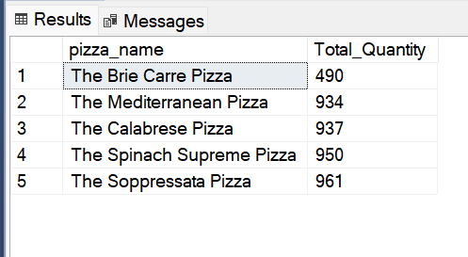

**14. Top 5 Pizzas by Total Orders**

SELECT TOP 5 pizza_name,count(distinct order_id) as Total_Orders from pizza_sales

group by pizza_name

order by Total_Orders desc

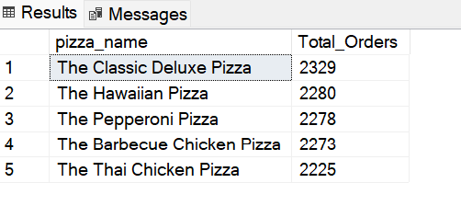

**15. Bottom 5 Pizzas by Total Orders**

SELECT TOP 5 pizza_name,count(distinct order_id) as Total_Orders from pizza_sales

group by pizza_name

order by Total_Orders asc

